# VIGNAN’S FOUNDATION FOR SCIENCE, TECHNOLOGY AND RESEARCH (Deemed to be UNIVERSITY)

**VADLAMUDI – 522 213, GUNTUR DIST, ANDHRA PRADESH, INDIA.**



**CERTIFICATE**

This is to certify that the Internship Report entitled **“ ”** that is being submitted by **Name(151FAXXXX)** in partial fulfilment for the award of B. Tech degree in Information Technology at Vignan’s Foundation for Science, Technology and Research, Deemed to be University, is a record of bonafide work carried out by them at **“Name of the organization”** under the supervision of **“Guide name at company”** under the co-guidance of the following faculty member of Department of IT.

# Project Guide Head of the Department

**DECLARATION**

I hereby declare that the project entitled “**XXXXXX**” submitted to the **DEPARTMENT OF INFORMATION TECHNOLOGY**. This REPORT is our original work and the project has not formed the basis for the award of any degree, associate-ship, and fellowship or any other similar titles and no part of it has been published or sent for publication at the time of submission.

By xxxxxx(151FA0xxxx) xxxxxx(151FA0xxxx)

Date: 20-April 2019.

# ACKNOWLEDGMENT

Internship program is a golden opportunity for learning and self-development. Consider myself very lucky and honoured to have so many wonderful people lead me through in the completion of this project.

I express my gratitude towards the Managing Director of **XXXXXX,** for permitting me to undertake the **Internship Program** in their extreme company and for the help and cooperation throughout the course of my Internship Program.

We feel it our responsibility to thank “Name of the guide” under whose valuable guidance that the project came out successfully after each stage, and also it is our responsibility to extend our thanks to **Dr. S. Thiruselvan, Department Internship Coordinator,** for extending his support towards the Internship Program in **“name of the organizationXXX”**, in **Hyderabad**.

It is a great pleasure for me to express my sincere thanks to **Prof. K. V. Krishna Kishore, HOD, IT** of VFSTR Deemed to be University**,** for providing me an opportunity to do my Internship Program.

We extend our wholehearted gratitude to all our faculty members of Department of Information Technology who helped us in our academics throughout course.

Finally, we wish to express thanks to our family members for the love and affection overseas and forbearance and cheerful depositions, which are vital for sustaining effort, required for completing this work.

With Sincere regards,

xxxxxx(151FA0xxxx) xxxxxx(151FA0xxxx)

|  |  |  |  |
| --- | --- | --- | --- |
| **TABLE OF CONTENTS** | | | |
|  |  | ***Title*** | ***Page No.*** |
|  | **TABLE OF CONTENTS** | | 04 |
| **1** | **INTRODUCTION** | |  |
|  | 1.1 Project Idea | | 12 |
|  | 1.2 | Overview | 13 |
|  | 1.3 | Modules | 14 |
| **2** | **SOFTWARE REQUIREMENT SPECIFICATION** | | |
|  | 2.1 Introduction | | 16 |
|  | 2.2 Functional Requirements | | 17 |
|  | 2.3 Non Functional Requirements | | 19 |
|  | 2.4 | Hardware Requirements | 22 |
|  | 2. 5 Software Requirements | | 22 |
| **3** | **ANALYSIS AND DESIGN PHASE** | |  |
|  | 3.1 Introduction | | 25 |
|  | 3.2 Class Diagram | | 25 |
|  | 3.3 | Object Diagram | 26 |
|  | 3.4 | Activity Diagram | 27 |
|  | 3.5 | Sequence Diagram | 28 |
|  | 3.6Collaboration Diagram | | 29 |
|  | 3.7State chart Diagram | | 30 |
| 3.8 Component Diagram | | | 31 |
|  | 3.9Deployment Diagram | | 31 |
|  | 3.10 Data Design | | 32 |
|  | 3.11 Conclusion | | 35 |

|  |  |
| --- | --- |
| **4 SYSTEM LOW LEVEL DESIGN** |  |
| 4.1 Modules of the project | 37 |
| 4.2 Objectives | 37 |
| 4.3 Project overview | 38 |
| **5 IMPLEMENTATION** |  |
| 5.1 Same Code | 41 |
| 5.2 Screen Captures | 52 |
| 5.3 Firebase Analytics | 59 |
| **6 TESTING** |  |
| 6.1 Software Testing | 63 |
| 6.2 Black Box Testing | 63 |
| 6.3White Box Testing | 63 |
| 6.4 Performance Testing | 63 |
| 6.5Load Testing | 63 |
| 6.6Manual Testing | 63 |
| 6.7Firebase Test Lab | 67 |
| **7 RESULTS AND CHALLENGES** |  |
| 7.1 Results | 70 |
| 7.2Challenges | 70 |
| **8 CONCLUSION AND FUTURE WORK** |  |
| 8.1 Conclusion | 72 |
| 8.2Scope for future work | 72 |
| 8.3Limitations | 72 |
| **BIBILOGRAPHY** | 73 |

## LIST OF FIGURES

|  |  |  |
| --- | --- | --- |
| **FIGURE NO** | **TITLE** | **PAGENO** |
| 2.1 | Use Case Diagram | 21 |
| 3.2 | Class Diagram | 25 |
| 3.3 | Object Diagram | 26 |
| 3.4 | Activity Diagram | 27 |
| 3.5 | Sequence diagram | 28 |
| 3.6 | Collaboration diagram | 29 |
| 3.7 | State Chart diagram | 30 |
| 3.8 | Component diagram | 30 |
| 3.9 | Deployment diagram | 31 |
| 5.2.1 | User login screen | 52 |
| 5.2.2 | Forgot password page | 52 |
| 5.2.3 | User sign up page | 53 |
| 5.2.4 | User home screen | 53 |
| 5.2.5 | Service page | 54 |
| 5.2.6 | Booking page | 54 |
| 5.2.7 | All bookings page | 55 |
| 5.2.8 | Referral page | 55 |
| 5.2.9 | User profile page | 56 |
| 5.2.10 | Service provider login page | 56 |
| 5.2.11 | Service provider signup page | 57 |
| 5.2.12 | Service provider bookings | 57 |
| 5.2.13 | Reference page | 58 |
| 5.2.14 | Service provider profile page | 58 |
| 5.3.1 | Firebase Authentication | 59 |
| 5.3.2 | Password reset mail template | 59 |
| 5.3.3 | Firebase Database | 60 |
| 5.3.4 | Active sessions | 60 |
| 5.3.5 | User engagement | 61 |

|  |  |  |
| --- | --- | --- |
| 6.1 | Test case for empty login | 64 |
| 6.2 | Test case for wrong login | 65 |
| 6.3 | Test case for signup fail | 66 |
| 6.4 | Test case for user signup fail | 67 |
| 6.7 | Firebase test lab clusters | 68 |

**LIST OF TABLES**

|  |  |  |
| --- | --- | --- |
| Table 3.10.1 | SQLite Database | 32 |
| Table 3.10.2 | List of tables in database | 32 |
| Table 3.10.3 | Admin table | 32 |
| Table 3.10.4 | Users table | 33 |
| Table 3.10.5 | Service providers table | 33 |
| Table 3.10.6 | Bookings table | 34 |
| Table 3.10.7 | Services table | 34 |
| Table 6:1 | Test case for empty login fields | 64 |
| Table 6:2 | Test case for wrong login fields | 64 |
| Table 6:3 | Test case for signup fail | 65 |
| Table 6:4 | Test case for User signup fail | 67 |

**ACRONYMS & ABBREVIATIONS**

|  |  |
| --- | --- |
| * **HTML:** | Hyper Text Markup Language. |
| * **XML:** | Extensible Markup Language. |
| * **IDE:** | Integrated Development Environment |
| * **PHP:** | Hyper Text Preprocessor |
| * **RDBMS:** | Relational Database Management System. |
| * **GUI:** | Graphical User Interface |
| * **HTTP:** | Hyper Text Transfer Protocol |
| * **API:** | Application Programming Interface |
| * **E-R:** | Entity-Relationship |
| * **UML:** | Unified Modeling Language |
| * **OOAD:** | Object-Oriented Analysis & Design. |

**INTERNSHIP SUMMARY**

**Location:**Hyderabad

**Center:** “Name of the organization”

**Duration:**

**Date of start:**

**Date of submission:**

**Title of project:**

**Team Members:**

xxxxxx(151FA0xxxx) xxxxxx(151FA0xxxx) **Name of the guide:**

**Name of Faculty guide:** VFSTR University. **Project Area: Bird Species Identification**

**Abstract:**

* Now a day some bird species are being found rarely and if found classification of bird species prediction is difficult. Naturally, birds present in various scenarios appear in different sizes, shapes, colors, and angles from human perspective. Besides, the images present strong variations to identify the bird species more than audio classification. Also, human ability to recognize the birds through the images is more understandable. So this method uses the Caltech-UCSD Birds 200 [CUB-200-2011] dataset for training as well as testing purpose. By using deep convolutional neural network (DCNN) algorithm an image converted into grey scale format to generate autograph by using tensor flow, where the multiple nodes of comparison are generated. These different nodes are compared with the testing dataset and score sheet is obtained from it. After analyzing the score sheet it can predicate the required bird species by using highest score.

**Signature of Student Signature of Faculty Guide**

**Date: Date:**

# PROFILE OF THE COMPANY

**About ECIL**

**Electronics Corporation of India Limited (ECIL)** is a Government of India Enterprise under the Department of Atomic Energy, established on April 11, 1967 by A. S. Rao at Hyderabad, to create a strong indigenous base in electronics. ECIL is a multi-product, multi- disciplinaryorganization with focus on indigenous Nuclear energy, space and Defense sectors. ECIL also has a strong presence in indigenous Electronic Security, Communications, Networking and e-governance domains. ECIL has committed partnerships with nuclear energy establishments of India, particularly Bhabha Atomic Research Center (BARC), Nuclear Power Corporation of India Limited (NPCIL) and Indira Gandhi Centre for Atomic Research (IGCAR). ECIL also actively supports other strategic sectors such as indigenous Defense (Defense Research and Development Organization(DRDO)), Space (Department of Space (India))Civil Aviation, Information and Broadcasting, Telecommunications, Insurance, Banking, Police and Para-military Forces, Oil and Gas, Power, Space Education, Health, Agriculture, Steel and Coal. ECIL is credited with producing the first indigenous digital computers, TDC 312 and TDC 316, solid state TV, control and instrumentation for nuclear power plants and first earth station antenna of India.

**Company address:**

A.S. Rao Nagar, ECIL, Hyderabad

***CHAPTER - 1***

***INTRODUCTION***

*The chapter gives brief introduction of the project.*

## CHAPTER 1 INTRODUCTION

* BIRD behavior and population trends have become an important issue now a days. Birds help us to detect other organisms in the environment (e.g. insects they feed on) easily as they respond quickly to the environmental changes [2]. But, gathering and collecting information about birds requires huge human effort as well as becomes a very costlier method. In such case, a reliable system that will provide large scale processing of information about birds and will serve as a valuable tool for researchers, governmental agencies, etc. is required. So, bird species identification plays an important role in identifying that a particular image of bird belongs to which species. Bird species identification means predicting the bird species belongs to which category by using an image. The identification can be done through image, audio or video. An audio processing technique makes it possible to identify by capturing the audio signal of birds. But, due to the mixed sounds in environment such as insects, objects from real world, etc. processing of such information becomes more complicated. Usually, human beings find images more effective than audios or videos. So, an approach to classify bird using an image over audio [8] or video is preferred. Bird species identification is a challenging task to humans as well as to computational

***CHAPTER - 2***

***SOFTWARE REQUIREMENT***

***SPECIFICATION***

*Gives the details of platform specifications, Hardware,and Software specifications.*

## CHAPTER 2 REQUIREMENT ANALYSIS

This chapter provides the details of the project’s need based survey, system requirements, Hardware Requirements, Software Requirements, and System Requirements.

**Project Overview :-**

In this paper author is describing concept to identify species of birds by using python TENSORFLOW and Deep Learning algorithm. Earlier technique were using birds voice or videos to predict it species but this technique will not give accurate result as audio may contains background or other animal voices. So images can be best option to identify species of birds.

**Existing System :-**

* In this paper, instead of recognizing a large number of disparate categories, the problem of recognizing a large number of classes within one category is investigated that of birds. Classifying birds pose an extra challenge over categories, because of the large similarity between classes. In addition, birds are non-rigid objects that can deform in many ways, and consequently there is also a large variation within classes. Previous work on bird classification has deal with a small number of classes, or through voice.
* To implement this technique we need to train all birds species and generate a model and then by uploading any image deep learning algorithm will convert uploaded image into gray scale format and apply that image on train model to predict best match species name for uploaded image.

**Proposed System :-**

* Represents the actual flow of the proposed system. To develop such system a trained dataset is required to classify an image. Trained dataset consists of two parts trained result and test result. The dataset has to be retrained to achieve higher accuracy in identification using retrain.py in Google Collab. The training dataset is made using 50000 steps taking into consideration that higher the number of steps higher is its accuracy. The accuracy of training dataset is 93%. The testing dataset consists of nearly 1000 images with an accuracy of 80%. dataset is validated with an accuracy of 75% to increase the performance of system. Whenever a user will upload an input file on website, the image is temporarily stored in database. This input file is then feed to system and given to CNN where CNN is coupled with trained dataset. A CNN consists of various convolutional layers. Various alignments/features such as head, body, color, beak, shape, entire image of bird are considered for classification to yield maximum accuracy

**Advantages :-**

* dataset is validated with an accuracy of 75% to increase the performance of system.

**Functional requirements :-**

In software engineering, a functional requirement defines a system or its component. It describes the functions a software must perform. A function is nothing but inputs, its behavior, and outputs. It can be a calculation, data manipulation, business process, user interaction, or any other specific functionality which defines what function a system is likely to perform.

Functional software requirements help you to capture the intended behavior of the system. This behavior may be expressed as functions, services or tasks or which system is required to perform.

**Non –Functional Requirements :-**

A non-functional requirement defines the quality attribute of a software system. They represent a set of standards used to judge the specific operation of a system. Example, how fast does the website load?

A non-functional requirement is essential to ensure the usability and effectiveness of the entire software system. Failing to meet non-functional requirements can result in systems that fail to satisfy user needs.

**Hardware Requirements :-**

* Operating System supported by

1. Windows 7

2. Windows XP

3 . Windows 8

* Processor – Pentium IV or higher
* RAM -- 256 MB
* Space on Hard Disk -- Minimum 512 MB

**Software Requirements :-**

* For developing the Application

1. Python

2. Django

3. Mysql

4. Mysqlclient

5. WampServer 2.4

* Technologies and Languages used to Develop

-- Python

### HOME PAGE:-

* XML
* JAVA

### REGISTRATIONPAGE:-

* XML
* JAVA

### LOGIN PAGE:-

* XML
* JAVA

### BOOKINGS PAGE

* XML
* JAVA

### REFERRALS PAGE

* XML
* JAVA

### PROFILE PAGE

* XML
* JAVA

### PREFERENCE PAGE

* XML
* JAVA

### SP LOGIN PAGE

* XML
* JAVA

### SP SIGN UP PAGE

* XML
* JAVA

### SP BOOKING PAGE

* XML
* JAVA

***CHAPTER - 3***

***ANALYSIS & DESIGN***

*This chapter gives the details of the system and data design.*

### CHAPTER 3 DESIGN PHASE

**INTRODUCTION**

This chapter provides the design phase of the Application. To design the project, we use the UML diagrams. The Unified Modelling Language (UML) is a general- purpose, developmental, modelling language in the field of software engineering that is intended to provide a standard way to visualize the design of a system.

### 3.1 USE CASE DIAGRAM

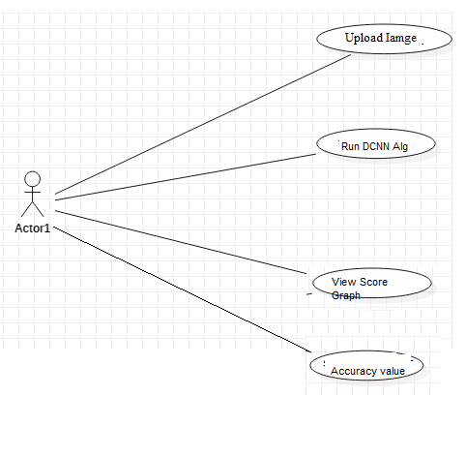

**Fig 2.1 Use case Diagram**

The use case diagram is used to represent all the functional use cases that are involved in the project.

The above diagram represents the main two **actors** in the project, they are

* + - User

### CLASS DIAGRAM

**Fig 3.2 class diagram**

The above mentioned class diagram represents the Chatbot system workflow model. This diagram has class models with class names as

* + - User
    - Home screen

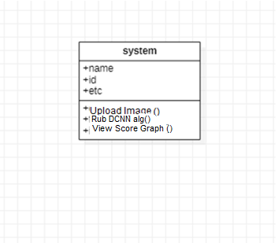

### SEQUENCE DIAGRAM

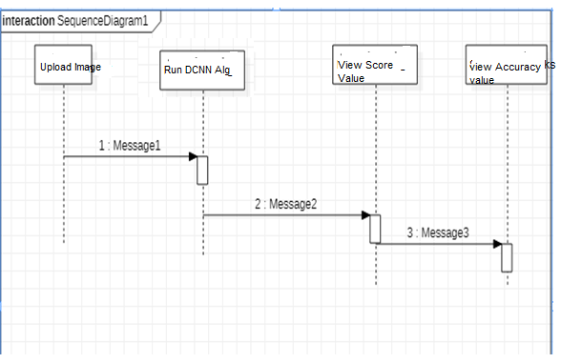

**Fig 3.5 sequence diagram**

The above diagram represents the sequence of flow of actions in the system.

### Activity DIAGRAM

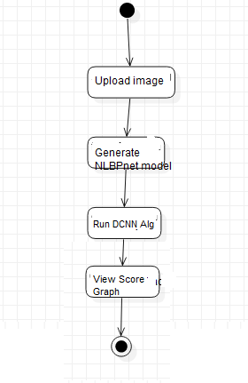

## DATA DESIGN

* + 1. **Databases SQLite**

|  |
| --- |
| **Name** |
| Bird Species |

**Table 3.10.1 SQLite Database**

* + 1. **Tables**

|  |  |
| --- | --- |
| **Name** | **Description** |
| Users | Contains all the registered user details. |
| View Score value | All the registered service provider details. |
| Services | Contains all the types of services available. |

**Table 3.10.2 List of Database Tables**

## CONCLUSION

* The present study investigated a method to identify the bird species using Deep learning algorithm (Unsupervised Learning) on the dataset (Caltech-UCSD Birds 200) for classification of image. It consists of 200 categories or 11,788 photos. The generated system is connected with a user-friendly website where user will upload photo for identification purpose and it gives the desired output. The proposed system works on the principle based on detection of a part and extracting CNN features from multiple convolutional layers. These features are aggregated and then given to the classifier for classification purpose. On basis of the results which has been produced, the system has provided the 80% accuracy in prediction of finding bird species.

***CHAPTER - 4***

***SYSTEM LOWLEVEL DESIGN***

*This chapter gives an overview of all modules in the project.*

### CHAPTER 4

**SYSTEM LOWLEVEL DESIGN**

This chapter mainly provides the overview on modules of the application, objectives of the project and a detailed project overview.

* 1. **Modules of the Application:**
* To implement this technique we need to train all birds species and generate a model and then by uploading any image deep learning algorithm will convert uploaded image into gray scale format and apply that image on train model to predict best match species name for uploaded image.
* To train bird species we are using ‘Caltech-UCSD Birds 200(CUB-200-2011)’ dataset which contains 200 species or categories of birds. Model will be built using that dataset and tensor flow deep learning algorithm.
  1. **OBJECTIVES OF THE PROJECT**

***CHAPTER - 5***

***IMPLEMENTATION***

*The chapter gives the details of the implementation.*

### CHAPTER 5 IMPLEMENTATION

This chapter mainly provides the sample code and implementation of the project.

* 1. **Sample Code**
     1. **XML Code page**

*<?***xml version="1.0" encoding="utf-8"***?>*

<**LinearLayoutxmlns:android="**[**http://schemas.android.com/apk/res/android**](http://schemas.android.com/apk/res/android)**" android:layout_width="match_parent" android:layout_height="match_parent"**

**android:orientation="vertical"**>

<**android.support.v7.widget.LinearLayoutCompat android:layout_width="match_parent" android:layout_height="150dp" android:background="@color/colorTextHint" android:gravity="center" android:orientation="vertical"**>

<**android.support.v7.widget.AppCompatTextView android:layout_width="wrap_content" android:layout_height="wrap_content" android:text="Bookings" android:textSize="20sp"** />

<**android.support.v7.widget.AppCompatTextView android:layout_width="wrap_content" android:layout_height="wrap_content" android:layout_marginTop="10dp" android:text="@string/text_hello"** />

<**android.support.v7.widget.AppCompatTextView android:id="@+id/textViewName" android:layout_width="wrap_content" android:layout_height="wrap_content"** />

</**android.support.v7.widget.LinearLayoutCompat**>

<**android.support.v7.widget.AppCompatTextView android:layout_width="wrap_content" android:layout_height="wrap_content" android:paddingBottom="5dp" android:paddingLeft="16dp" android:paddingTop="5dp" android:text="Bookings" android:textColor="@android:color/black"** />

<**ScrollView android:id="@+id/scrollview" android:layout_width="fill_parent" android:layout_height="fill_parent" android:layout_below="@+id/spinner1" android:layout_alignParentBottom="true" android:layout_alignParentLeft="true"** >

<**LinearLayout android:layout_width="match_parent" android:layout_height="562dp" android:layout_marginBottom="200dp" android:orientation="vertical"** >

<**ListView**

**android:id="@+id/listView1" android:layout_width="wrap_content" android:layout_height="600dp" android:layout_marginLeft="0dp"** >

</**ListView**>

</**LinearLayout**>

</**ScrollView**>

</**LinearLayout**>

* + 1. **Java Code page**

**package** com.example.spaceimpactor.houser.activities;

**import** java.util.ArrayList; **import** android.os.Bundle; **import** android.app.Activity; **import** android.content.Context; **import** android.content.Intent; **import** android.database.Cursor;

**import** android.database.sqlite.SQLiteDatabase;

**import** android.view.View;

**import** android.view.View.OnClickListener; **import** android.widget.AdapterView; **import** android.widget.ArrayAdapter; **import** android.widget.Button;

**import** android.widget.EditText; **import** android.widget.ImageView; **import** android.widget.ListView; **import** android.widget.Spinner; **import** android.widget.TextView;

**import** android.widget.AdapterView.OnItemClickListener;

**import** android.widget.Toast;

**import** com.example.spaceimpactor.houser.R;

**public class** Bookings **extends** Activity{ Spinner **sp**;

ImageView**out**; TextView**aaa**; SQLiteDatabase**db**; ListView**l**; EditText**t1**;

ArrayList<String>**list1**; ArrayAdapter**adapter**;

Button **sub**;

String **lmb**,**lser**,**lem**;

@Override

**protected void** onCreate(Bundle savedInstanceState) { **super**.onCreate(savedInstanceState); setContentView(R.layout.***activity_bookings***);

**final** GlobalClassglobalvariabel=(GlobalClass)getApplicationContext(); **aaa**=(TextView)findViewById(R.id.***textViewName***); **aaa**.setText(globalvariabel.GetUsername().toString());

**db**=openOrCreateDatabase(**"ServiceProvider"**, Context.***MODE_PRIVATE***, **null**); **l** = (ListView) findViewById(R.id.***listView1***);

**final** ArrayList<String> list = **new** ArrayList<String>();

**list1** = **new** ArrayList<String>();

Cursor res = **db**.rawQuery(**"SELECT * FROM book where uid='"** + **aaa**.getText() + **"'"**, **null**); **if** (res.getCount() != 0) {

**while** (res.moveToNext()) {

list.add(**"Name: "** + res.getString(1) + **"\nMobile No: "** + res.getString(2) + **"\n"** + **"Service Type: "** + res.getString(3) + **"\n"** + **"Email: "** + res.getString(4)+ **"\n"** + **"Booking Date: "** + res.getString(5));

**list1**.add(res.getString(1));

}

}

**adapter** = **new** ArrayAdapter<String>(**this**, android.R.layout.***simple_list_item_1***, list);

**l**.setAdapter(**adapter**);

}

}

* + 1. **Java Code**

**package** com.example.spaceimpactor.houser.fragment;

**import** android.content.Context;

**import** android.content.Intent;

**import** android.database.sqlite.SQLiteDatabase;

**import** android.os.Bundle;

**import** android.support.annotation.NonNull; **import** android.support.v4.app.Fragment; **import** android.text.TextUtils;

**import** android.util.Log;

**import** android.view.LayoutInflater;

**import** android.view.View;

**import** android.view.ViewGroup;

**import** android.support.annotation.Nullable;

**import** android.support.design.widget.Snackbar;

**import** android.support.design.widget.TextInputEditText; **import** android.support.design.widget.TextInputLayout; **import** android.support.v4.widget.NestedScrollView; **import** android.support.v7.app.AppCompatActivity; **import** android.support.v7.widget.AppCompatButton; **import** android.support.v7.widget.AppCompatTextView; **import** android.widget.Button;

**import** android.widget.EditText; **import** android.widget.ProgressBar; **import** android.widget.TextView; **import** android.widget.Toast;

**import** com.google.firebase.auth.FirebaseAuth; **import** com.google.firebase.auth.FirebaseUser; **import** com.google.firebase.database.DataSnapshot; **import** com.google.firebase.database.DatabaseError;

**import** com.google.firebase.database.DatabaseReference; **import** com.google.firebase.database.FirebaseDatabase; **import** com.google.firebase.database.ValueEventListener;

**public class** ProfileFragment**extends** Fragment **implements** View.OnClickListener {

**private** NestedScrollView**nestedScrollView**;

**private** TextInputLayout**textInputLayoutName**; **private** TextInputLayout**textInputLayoutPhone**; **private** TextInputLayout**textInputLayoutEmail**; **private** TextInputLayout**textInputLayoutPassword**;

**private** TextInputLayout**textInputLayoutConfirmPassword**;

**private** TextInputEditText**textInputEditTextName**; **private** TextInputEditText**textInputEditTextPhone**; **private** TextInputEditText**textInputEditTextEmail**; **private** TextInputEditText**textInputEditTextPassword**;

**private** TextInputEditText**textInputEditTextConfirmPassword**;

**private** AppCompatButton**appCompatButtonRegister**;

**private** InputValidation**inputValidation**; **private** DatabaseHelper**databaseHelper**; **private** User **user**;

EditText**id**,**ps**,**em**,**mb**; Button **sub**;

SQLiteDatabase**db**; TextView**aaa**;

**private static final** String ***TAG*** = MainActivity.**class**.getSimpleName();

**private** TextView**txtDetails**;

**private** EditText**inputName**, **inputEmail**; **private** Button **btnSave**;

**private** DatabaseReference**mFirebaseDatabase**;

**private** FirebaseDatabase**mFirebaseInstance**;

**private** String **userId**;

**private** Button **btnChangeEmail**, **btnChangePassword**, **btnSendResetEmail**, **btnRemoveUser**, **changeEmail**, **changePassword**, **sendEmail**, **remove**, **signOut**;

**private** EditText**oldEmail**, **newEmail**, **password**, **newPassword**; **private** ProgressBar**progressBar**;

**private** FirebaseAuth.AuthStateListener**authListener**;

**private** FirebaseAuth**auth**;

@Override

**public** View onCreateView(LayoutInflaterinflater, ViewGroup container, Bundle savedInstanceState) {

*// Inflate the layout for this fragment*

View myView = inflater.inflate(R.layout.***fragment_profile***, container, **false**);

*// appCompatButtonRegister = (AppCompatButton) myView.findViewById(R.id.appCompatButtonRegister);*

*// appCompatButtonRegister.setOnClickListener(this);*

**return** myView;

}

**private void** createUser(String name, String email) {

*//* ***TODO***

*// In real apps this userId should be fetched*

*// by implementing firebase auth*

**if** (TextUtils.*isEmpty*(**userId**)) {

**userId**= **mFirebaseDatabase**.push().getKey();

}

User user = **new** User();

**mFirebaseDatabase**.child(**userId**).setValue(user); addUserChangeListener();

}

*/\*\**

* *User data change listener*

*\*/*

**private void** addUserChangeListener() {

*// User data change listener* **mFirebaseDatabase**.child(**userId**).addValueEventListener(**new** ValueEventListener() { @Override

**public void** onDataChange(DataSnapshotdataSnapshot) { User user = dataSnapshot.getValue(User.**class**);

*// Check for null*

**if** (user == **null**) {

Log.*e*(***TAG***, **"User data is null!"**); **return**;

}

**inputEmail**.setText(**""**); **inputName**.setText(**""**);

}

@Override

**public void** onCancelled(DatabaseError error) {

*// Failed to read value*

Log.*e*(***TAG***, **"Failed to read user"**, error.toException());

}

});

}

**private void** updateUser(String name, String email) {

*// updating the user via child nodes*

**if** (!TextUtils.*isEmpty*(name))

**mFirebaseDatabase**.child(**userId**).child(**"name"**).setValue(name);

**if** (!TextUtils.*isEmpty*(email))

**mFirebaseDatabase**.child(**userId**).child(**"email"**).setValue(email);

}

*//sign out method* **public void** signOut() { **auth**.signOut();

}

@Override

**public void** onResume() { **super**.onResume(); **progressBar**.setVisibility(View.***GONE***);

}

@Override

**public void** onStart() {

**super**.onStart(); **auth**.addAuthStateListener(**authListener**);

}

@Override

**public void** onStop() {

**super**.onStop();

**if** (**authListener**!= **null**) {

**auth**.removeAuthStateListener(**authListener**);

}

}

**public void** onViewCreated(@NonNullView view, @NullableBundle savedInstanceState) {

**super**.onViewCreated(view, savedInstanceState);

*// initViews();*

*// initObjects();*

**auth**= FirebaseAuth.*getInstance*();

*//get current user*

**final** FirebaseUser user = FirebaseAuth.*getInstance*().getCurrentUser();

**authListener**= **new** FirebaseAuth.AuthStateListener() { @Override

**public void** onAuthStateChanged(@NonNullFirebaseAuthfirebaseAuth) { FirebaseUser user = firebaseAuth.getCurrentUser();

**if** (user == **null**) {

*// user auth state is changed - user is null*

*// launch login activity*

startActivity(**new** Intent(getActivity(), LoginActivity.**class**));

}

}

};

*// btnChangeEmail = (Button) findViewById(R.id.change_email_button);*

*//btnChangePassword = (Button) findViewById(R.id.change_password_button);* **btnSendResetEmail**= (Button) getView().findViewById(R.id.***sending_pass_reset_button***); **btnRemoveUser**= (Button) getView().findViewById(R.id.***remove_user_button***);

*// changeEmail = (Button) getView().findViewById(R.id.changeEmail);*

*// changePassword = (Button) getView().findViewById(R.id.changePass);*

**sendEmail**= (Button) getView().findViewById(R.id.***send***); **remove** = (Button) getView().findViewById(R.id.***remove***); **signOut**= (Button) getView().findViewById(R.id.***sign_out***);

**oldEmail**= (EditText) getView().findViewById(R.id.***old_email***); **newEmail**= (EditText) getView().findViewById(R.id.***new_email***); **password** = (EditText) getView().findViewById(R.id.***password***); **newPassword**= (EditText) getView().findViewById(R.id.***newPassword***);

**oldEmail**.setVisibility(View.***GONE***); **newEmail**.setVisibility(View.***GONE***); **password**.setVisibility(View.***GONE***); **newPassword**.setVisibility(View.***GONE***);

*// changeEmail.setVisibility(View.GONE);*

*// changePassword.setVisibility(View.GONE);* **sendEmail**.setVisibility(View.***GONE***); **remove**.setVisibility(View.***GONE***);

**progressBar**= (ProgressBar) getView().findViewById(R.id.***progressBar***);

**if** (**progressBar**!= **null**) {

**progressBar**.setVisibility(View.***GONE***);

}

**btnSendResetEmail**.setOnClickListener(**new** View.OnClickListener() { @Override

**public void** onClick(View v) { **oldEmail**.setVisibility(View.***VISIBLE***); **newEmail**.setVisibility(View.***GONE***); **password**.setVisibility(View.***GONE***); **newPassword**.setVisibility(View.***GONE***);

*// changeEmail.setVisibility(View.GONE);*

*// changePassword.setVisibility(View.GONE);* **sendEmail**.setVisibility(View.***VISIBLE***); **remove**.setVisibility(View.***GONE***);

}

});

**sendEmail**.setOnClickListener(**new** View.OnClickListener() { @Override

**public void** onClick(View v) {

**progressBar**.setVisibility(View.***VISIBLE***);

**if** (!**oldEmail**.getText().toString().trim().equals(**""**)) {

**auth**.sendPasswordResetEmail(**oldEmail**.getText().toString().trim())

.addOnCompleteListener(**new** OnCompleteListener<Void>() {

@Override

**public void** onComplete(@NonNullTask<Void> task) {

**if** (task.isSuccessful()) {

Toast.*makeText*(getActivity(), **"Reset password email is sent!"**, Toast.***LENGTH_SHORT***).show();

**progressBar**.setVisibility(View.***GONE***);

} **else** {

Toast.*makeText*(getActivity(), **"Failed to send reset email!"**, Toast.***LENGTH_SHORT***).show();

**progressBar**.setVisibility(View.***GONE***);

}

}

});

} **else** {

**oldEmail**.setError(**"Enter email"**); **progressBar**.setVisibility(View.***GONE***);

}

}

});

**btnRemoveUser**.setOnClickListener(**new** View.OnClickListener() { @Override

**public void** onClick(View v) {

**progressBar**.setVisibility(View.***VISIBLE***);

**if** (user != **null**) { user.delete()

@Override

.addOnCompleteListener(**new** OnCompleteListener<Void>() {

**public void** onComplete(@NonNullTask<Void> task) {

**if** (task.isSuccessful()) {

Toast.*makeText*(getActivity(), **"Your profile is deleted:( Create a account now!"**, Toast.***LENGTH_SHORT***).show(); startActivity(**new** Intent(getActivity(), RegisterActivity.**class**));

*// finish();*

**progressBar**.setVisibility(View.***GONE***);

} **else** {

Toast.*makeText*(getActivity(), **"Failed to delete your account!"**, Toast.***LENGTH_SHORT***).show();

**progressBar**.setVisibility(View.***GONE***);

}

}

});

}

}

});

**signOut**.setOnClickListener(**new** View.OnClickListener() { @Override

**public void** onClick(View v) { signOut();

}

});

*//txtDetails = (TextView) findViewById(R.id.txt_user);* **inputName**= (EditText) getView().findViewById(R.id.***name***); **inputEmail**= (EditText) getView().findViewById(R.id.***email***); **btnSave**= (Button) getView().findViewById(R.id.***btn_save***);

**mFirebaseInstance**= FirebaseDatabase.*getInstance*();

*// get reference to 'users' node*

**mFirebaseDatabase**= **mFirebaseInstance**.getReference(**"users"**);

*// store app title to 'app_title' node*

**mFirebaseInstance**.getReference(**"app_title"**).setValue(**"Houser"**);

*// app_title change listener* **mFirebaseInstance**.getReference(**"app_title"**).addValueEventListener(**new** ValueEventListener() { @Override

**public void** onDataChange(DataSnapshotdataSnapshot) { Log.*e*(***TAG***, **"App title updated"**);

String appTitle = dataSnapshot.getValue(String.**class**);

*// update toolbar title*

*//getSupportActionBar().setTitle(appTitle);*

}

@Override

**public void** onCancelled(DatabaseError error) {

*// Failed to read value*

Log.*e*(***TAG***, **"Failed to read app title value."**, error.toException());

}

});

*// Save / update the user* **btnSave**.setOnClickListener(**new** View.OnClickListener() { @Override

**public void** onClick(View view) {

String name = **inputName**.getText().toString(); String email = **inputEmail**.getText().toString();

*// Check for already existed userId* **if** (TextUtils.*isEmpty*(**userId**)) { createUser(name, email);

} **else** {

updateUser(name, email);

}

}

});

}

@Override

**public void** onClick(View v) { postDataToSQLite();

}

**private void** initViews() {

**nestedScrollView**= (NestedScrollView) getView().findViewById(R.id.***nestedScrollView***);

**textInputLayoutName**= (TextInputLayout) getView().findViewById(R.id.***textInputLayoutName***); **textInputLayoutPhone**= (TextInputLayout) getView().findViewById(R.id.***textInputLayoutPhone***); **textInputLayoutEmail**= (TextInputLayout) getView().findViewById(R.id.***textInputLayoutEmail***); **textInputLayoutPassword**= (TextInputLayout) getView().findViewById(R.id.***textInputLayoutPassword***); **textInputLayoutConfirmPassword**= (TextInputLayout) getView().findViewById(R.id.***textInputLayoutConfirmPassword***);

**textInputEditTextName**= (TextInputEditText) getView().findViewById(R.id.***textInputEditTextName***); **textInputEditTextPhone**= (TextInputEditText) getView().findViewById(R.id.***textInputEditTextPhone***); **textInputEditTextEmail**= (TextInputEditText) getView().findViewById(R.id.***textInputEditTextEmail***); **textInputEditTextPassword**= (TextInputEditText) getView().findViewById(R.id.***textInputEditTextPassword***); **textInputEditTextConfirmPassword**= (TextInputEditText) getView().findViewById(R.id.***textInputEditTextConfirmPassword***);

}

**private void** initObjects() {

**inputValidation**= **new** InputValidation(getActivity()); **databaseHelper**= **new** DatabaseHelper(getActivity()); **user** = **new** User();

}

**private void** postDataToSQLite() {

**if** (!**inputValidation**.isInputEditTextFilled(**textInputEditTextName**, **textInputLayoutName**, getString(R.string.***error_message_name***))) {

**return**;

}

**if** (!**inputValidation**.isInputEditTextFilled(**textInputEditTextPhone**, **textInputLayoutPhone**, **"Enter Phone Number"**)) {

**return**;

}

**if** (!**inputValidation**.isInputEditTextFilled(**textInputEditTextEmail**, **textInputLayoutEmail**, getString(R.string.***error_message_email***))) {

**return**;

}

**if** (!**inputValidation**.isInputEditTextFilled(**textInputEditTextEmail**, **textInputLayoutEmail**, getString(R.string.***error_message_email***))) {

**return**;

}

**if** (!**inputValidation**.isInputEditTextEmail(**textInputEditTextEmail**, **textInputLayoutEmail**, getString(R.string.***error_message_email***))) {

**return**;

}

**if** (!**inputValidation**.isInputEditTextPhone(**textInputEditTextPhone**, **textInputLayoutPhone**, getString(R.string.***error_message_phone***))) {

**return**;

}

**if** (!**inputValidation**.isInputEditTextFilled(**textInputEditTextPassword**, **textInputLayoutPassword**,

getString(R.string.***error_message_password***))) {

**return**;

}

**if** (!**inputValidation**.isInputEditTextMatches(**textInputEditTextPassword**, **textInputEditTextConfirmPassword**, **textInputLayoutConfirmPassword**, getString(R.string.***error_password_match***))) {

**return**;

}

**if** (!**databaseHelper**.checkUser(**textInputEditTextEmail**.getText().toString().trim())) {

**user**.setName(**textInputEditTextName**.getText().toString().trim()); **user**.setPhone(**textInputEditTextPhone**.getText().toString().trim()); **user**.setEmail(**textInputEditTextEmail**.getText().toString().trim()); **user**.setPassword(**textInputEditTextPassword**.getText().toString().trim());

**databaseHelper**.updateUser(**user**); emptyInputEditText();

}

}

**private void** emptyInputEditText()

{

**textInputEditTextName**.setText(**null**); **textInputEditTextPhone**.setText(**null**); **textInputEditTextEmail**.setText(**null**); **textInputEditTextPassword**.setText(**null**); **textInputEditTextConfirmPassword**.setText(**null**);

}

}

**5.1.3 XML Code**

*<?***xml version="1.0" encoding="utf-8"***?>*

<**android.support.v4.widget.NestedScrollView xmlns:android="**[**http://schemas.android.com/apk/res/android**](http://schemas.android.com/apk/res/android)**" xmlns:tools="**[**http://schemas.android.com/tools**](http://schemas.android.com/tools)**"**

**xmlns:app="**[**http://schemas.android.com/apk/res-auto**](http://schemas.android.com/apk/res-auto)**" android:id="@+id/nestedScrollView" android:layout_width="match_parent" android:layout_height="match_parent" android:paddingBottom="20dp" android:paddingLeft="20dp" android:paddingRight="20dp" android:paddingTop="20dp"**>

<**LinearLayout android:layout_width="match_parent" android:layout_height="wrap_content" android:orientation="vertical"**

**android:paddingBottom="@dimen/activity_vertical_margin" android:paddingLeft="@dimen/activity_horizontal_margin" android:paddingRight="@dimen/activity_horizontal_margin" android:paddingTop="0dp" app:layout_behavior="@string/appbar_scrolling_view_behavior"**>

<**TextView android:layout_width="match_parent" android:layout_height="match_parent"**

**android:text="Update your Profile" android:textColor="@android:color/black" android:textStyle="bold" android:textSize="30sp" android:layout_marginBottom="70dp" android:gravity="center"**/>

<**EditText android:id="@+id/old_email" android:layout_width="match_parent" android:layout_height="wrap_content" android:hint="Confirm Email"**

**android:inputType="textEmailAddress" android:maxLines="1" android:singleLine="true"** />

<**EditText android:id="@+id/new_email" android:layout_width="match_parent" android:layout_height="wrap_content" android:hint="New Email" android:inputType="textEmailAddress" android:maxLines="1" android:singleLine="true"** />

<**EditText android:id="@+id/password" android:layout_width="match_parent" android:layout_height="wrap_content" android:focusableInTouchMode="true" android:hint="@string/hint_password" android:imeActionId="@+id/login"**

**android:imeOptions="actionUnspecified" android:inputType="textPassword" android:maxLines="1" android:singleLine="true" tools:ignore="InvalidImeActionId"** />

<**EditText android:id="@+id/newPassword" android:layout_width="match_parent" android:layout_height="wrap_content" android:focusableInTouchMode="true" android:hint="New Password" android:imeActionId="@+id/login" android:imeOptions="actionUnspecified" android:inputType="textPassword" android:maxLines="1" android:singleLine="true" tools:ignore="InvalidImeActionId"** />

<**Button android:id="@+id/send"**

**style="?android:textAppearanceSmall" android:layout_width="wrap_content" android:layout_height="wrap_content" android:layout_marginTop="16dp" android:background="@android:color/black" android:text="Send" android:textColor="@android:color/white" android:textStyle="bold" android:layout_gravity="end"**/>

<**ProgressBar android:id="@+id/progressBar" android:layout_width="30dp" android:layout_height="30dp" android:visibility="gone"** />

<**Button android:id="@+id/remove"**

**style="?android:textAppearanceSmall" android:layout_width="wrap_content" android:layout_height="wrap_content" android:layout_marginTop="16dp" android:background="@color/colorPrimaryDark" android:text="Remove" android:textColor="@android:color/white" android:textStyle="bold"** />

<**android.support.design.widget.TextInputLayout android:layout_width="match_parent" android:layout_height="wrap_content"**>

<**EditText android:id="@+id/name"**

**android:layout_width="match_parent" android:layout_height="wrap_content" android:hint="Name" android:inputType="textCapWords" android:maxLines="1"** />

</**android.support.design.widget.TextInputLayout**>

<**android.support.design.widget.TextInputLayout android:layout_width="match_parent" android:layout_height="wrap_content"**>

<**EditText android:id="@+id/email"**

**android:layout_width="match_parent" android:layout_height="wrap_content" android:hint="Email" android:inputType="textEmailAddress" android:maxLines="1"** />

</**android.support.design.widget.TextInputLayout**>

## Screen Captures

* + 1. **User Login Screen:**

To test this application i am using below images

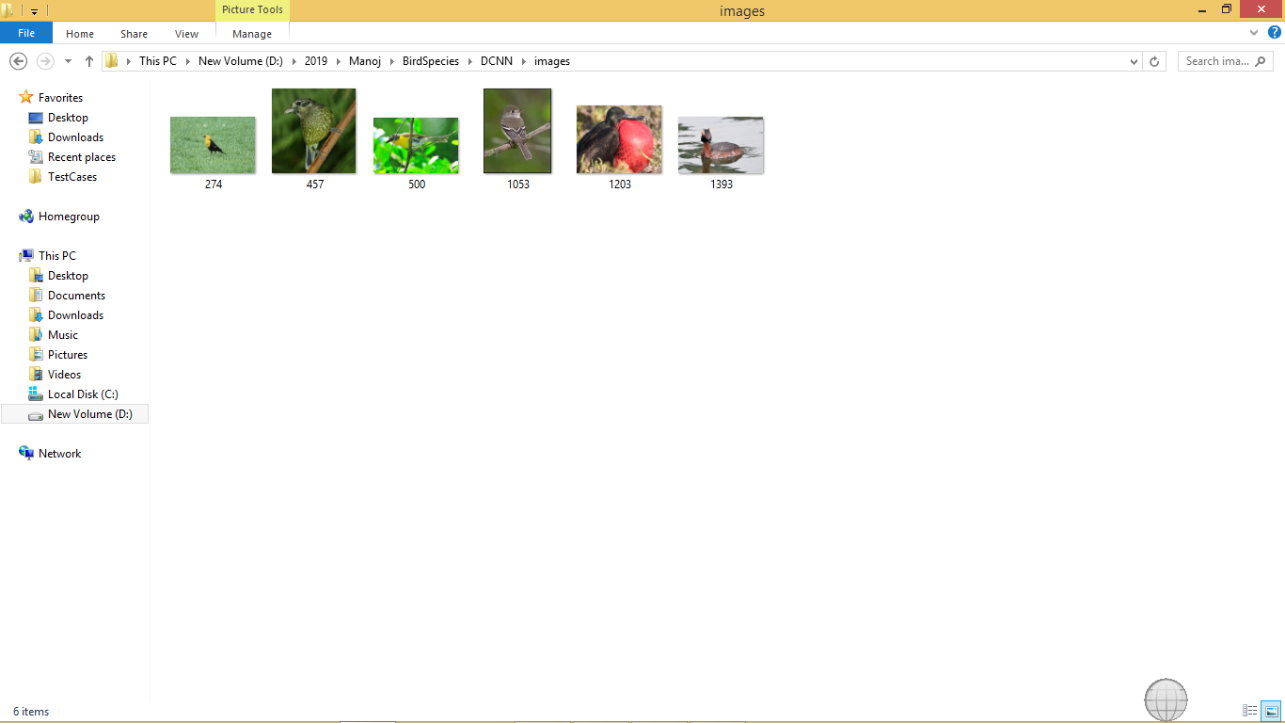

In above screen some bird’s images are there but we don’t know its name or species name. So by uploading this image to application we can get their species name

Screen shots

To run this project double click on ‘run.bat’ file to get below screen

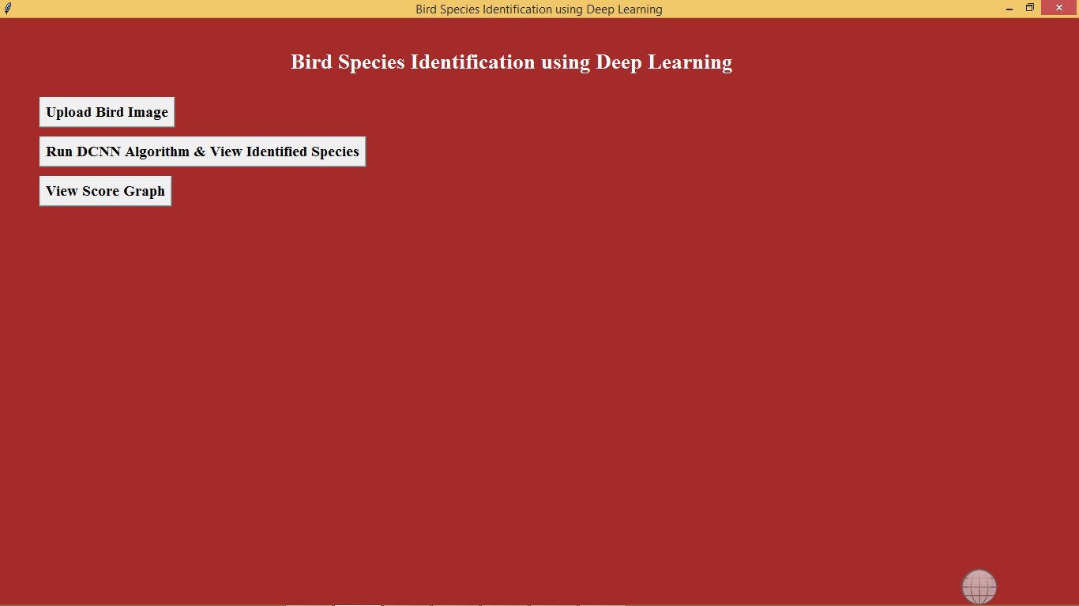

In above screen click on ‘Upload Bird Image’ button to upload bird image

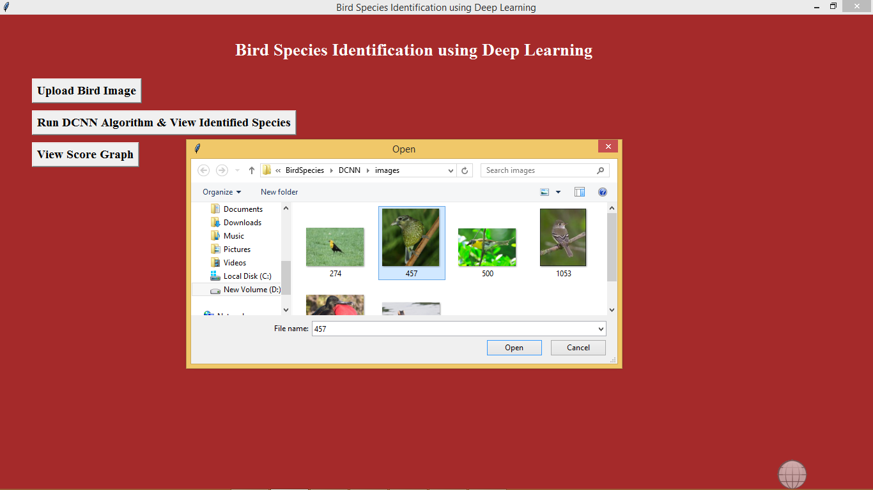

In above screen i am uploading one image of bird called ‘457.jpg’. After upload will get below screen

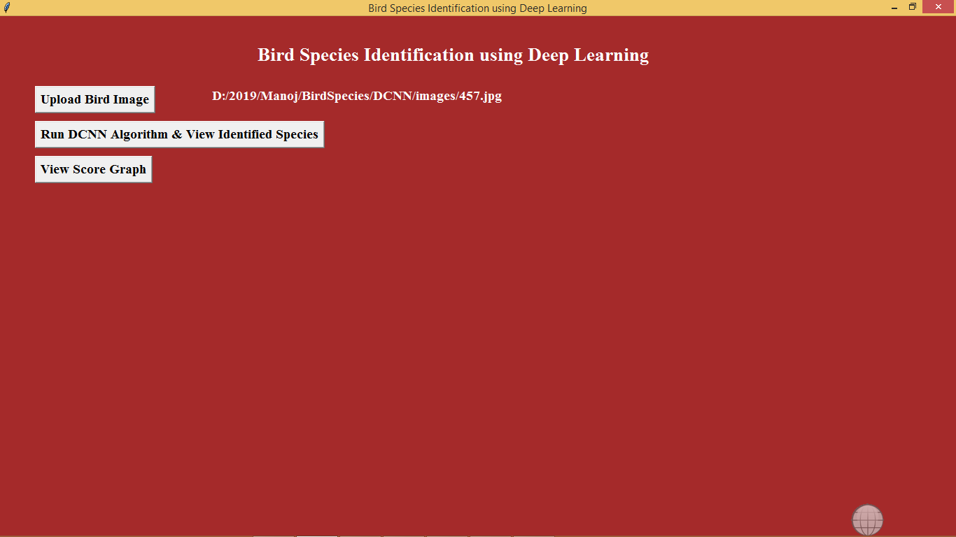

Now click on ‘Run DCNN Algorithm & View Identified Species’ button to know the species name of uploaded bird

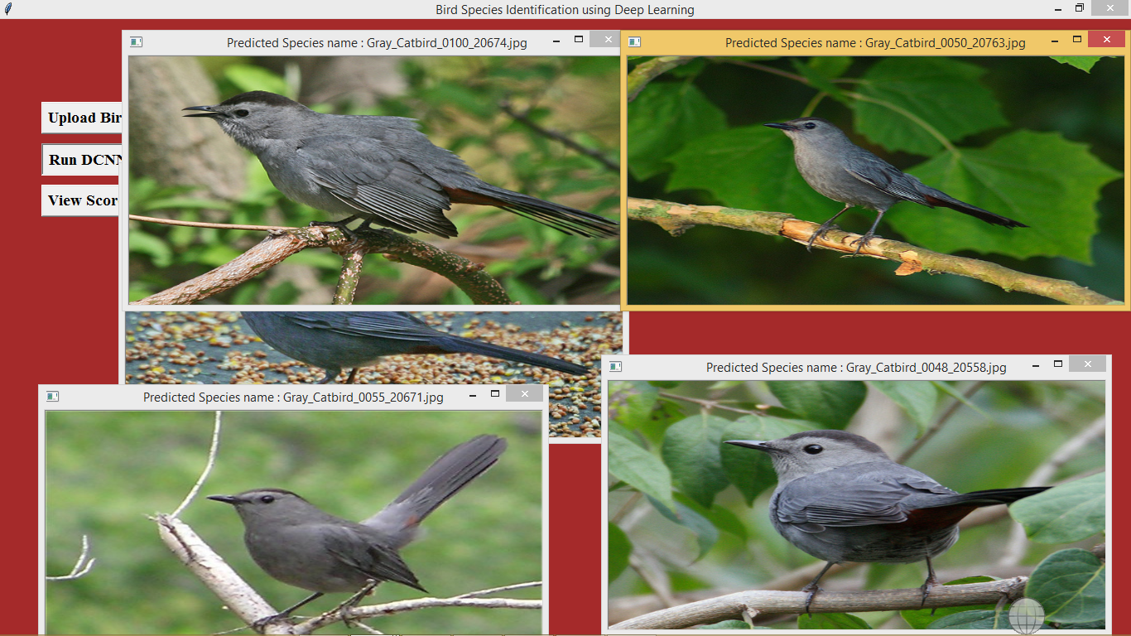

In above screen we got 5 related birds images of uploaded image and we can see the species name of bird on title bar of image.  So by uploading any image we can know the name of bird. You can upload any image and get it name and uploading image name should be as integer value.

Now click on ‘View Score Graph’ button to view the graph

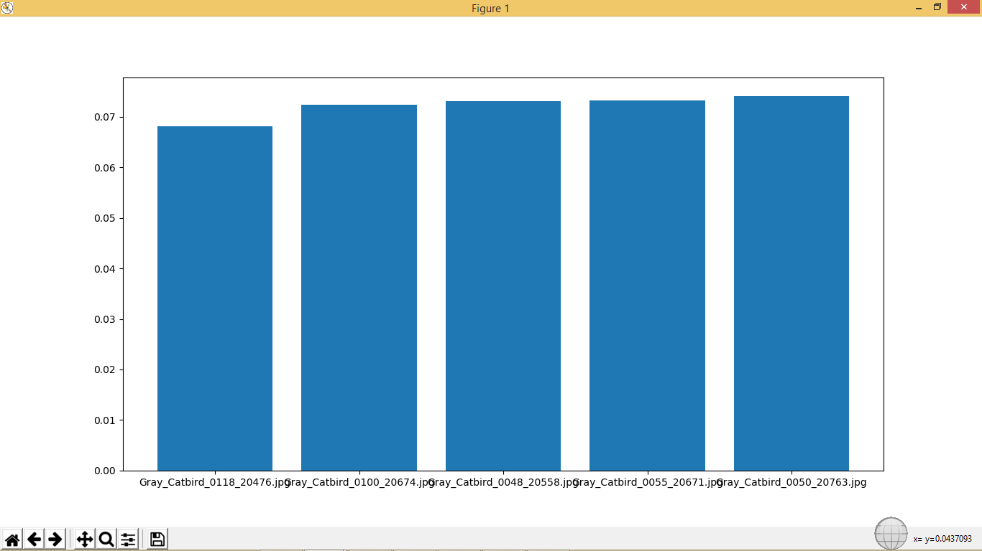

In above graph we got matching score of all 5 related birds and in above graph x-axis represents name of bird and y-axis represents matching score.

Accuracy value of this algorithm you can see in below screen

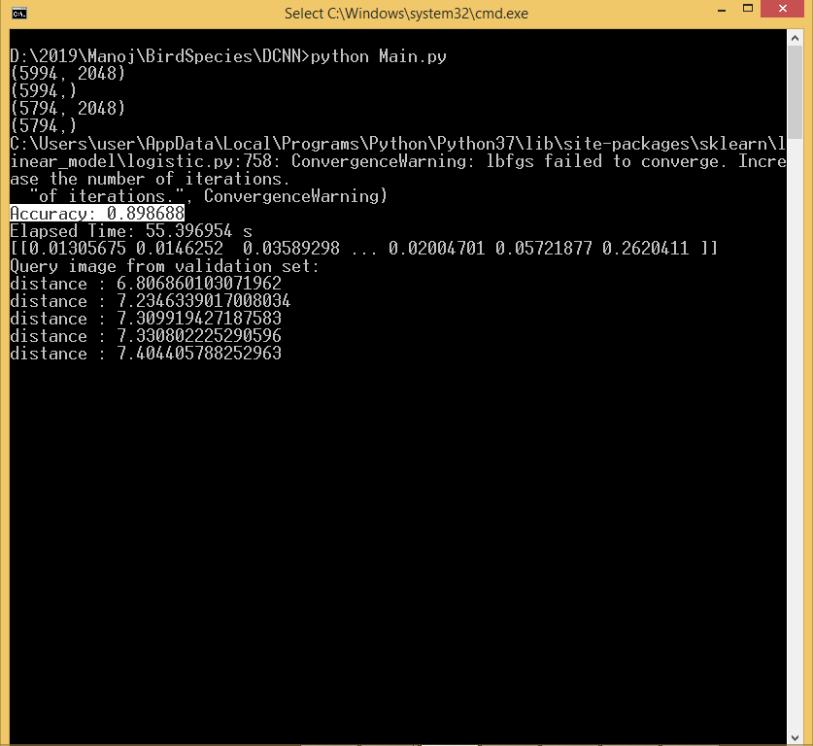

In above screen in selected text you can see Accuracy value.

***CHAPTER - 6***

***TESTING***

*The chapter shows the various test cases.*

# CHAPTER 6

## Software Testing

Software testing is the process of validating and verifying that a software applicationmeets the technical requirements which are involved in its design and development. It is alsoused to uncover any defects/bugs that exist in the application. It assures the quality of thesoftware. There are many types of testing software viz., manual testing, unit testing, black box testing, performance testing, stress testing, regression testing, white box testing etc. Among theseperformance testing and load testing are the most important one for an android application and nextsections deal with some of these types.

## Black box Testing

Black box testing treats the software as a "black box"—without any knowledge of internal implementation. Black box testing methods include equivalence partitioning, boundary value analysis, all-pairs testing, fuzz testing, model-based testing, traceability matrix, exploratory testing,and specification-based testing.

## White box Testing

White box testing is when the tester has access to the internal data structures and algorithms including the code that implement these.

## Performance Testing

Performance testing is executed to determine how fast a system or sub-system performsunder a particular workload. It can also serve to validate and verify other quality attributes of thesystem such as scalability, reliability and resource usage.

## Load Testing

Load testing is primarily concerned with testing that can continue to operate underspecific load, whether that is large quantities of data or a large number of users.

## Manual Testing

Manual Testing is the process of manually testing software for defects. Functionality of this application is manually tested to ensure the correctness. Few examples of test case for Manual Testing are discussed later in this chapter.

|  |  |
| --- | --- |
| **Test Case 1** | |
| Test Case Name | Empty login fields testing |
| Description | In the login screen if the username and password fields are empty |
| Output | Login fails showing an alert box asking to enter username and  password. |

**Table 6:1 Test Case for Empty Login Fields**

**Figure 6-1 Test Case for Empty Login Fields**

|  |  |
| --- | --- |
| **Test Case 2** | |
| Test Case Name | Wrong login fields testing |
| Description | A unique username and password are set by administrator. On entering wrong username or password gives. |
| Output | Login fails showing an alert box username or password  incorrect. |

**Table 6:2 Test Case for Wrong Login Fields**

**Figure 6-2 Test Case for Wrong Login Fields**

|  |  |
| --- | --- |
| **Test Case 3** | |
| Test Case Name | User Signup Fails. |
| Description | User signup need to provide all data. |
| Output | Signup Fails and an alert message appears asking to enter valid email and name. |

**Table 6:3 Test Case for Signup fail**

***CHAPTER - 7***

***RESULTS &CHALLENGES***

*The chapter describes the results and challenges faced in the project.*

# CHAPTER 7

**RESULTS AND CHALLENGES**

## Results

The current android application is developed using Xml, Java, SQL with Firebase connectivity. It can be used by every individual who are in a need of fulfilling their household services.

At the time of submission of my application was capable of doing the following:

* + Displaying thehome screen with different fragments.
  + Authentication of user by using login screen using Firebase.
  + Home screen to display based on user or service provider.
  + After successful login of user, they can choose the service and book a slot of their particular service provider from the displayed list.
  + Add, update, view, delete the user details.
  + After successful login of service provider, they can view all the bookings that are booked by the users and can attend them one by one.
  + Service provider can also set his preferences to not available, if he’s too busy or many users had already booked him.
  + Service provider has the ability to change their particular radius of location for servicing.
  + He can set up to 10 km radius.
  + Logout and end the session.

## Challenges

* + - Understanding the connections of SQLite Database is a tricky part and confusing when dealing with multiple tables within a database.
    - Making exact orientation API design levels was a difficult task as there are many types of devices like desktop, tablet, mobile with varying screen size and resolutions.
    - Implementing synchronization with Firebasewas a challenging task.
    - Learning different technologies and frameworks with little guidance.

***CHAPTER - 8***

***CONCLUSIONS & FUTURE WORK***

*The chapter gives brief conclusion about the project.*

# CHAPTER 8

# CONCLUSION

## Conclusion

* The present study investigated a method to identify the bird species using Deep learning algorithm (Unsupervised Learning) on the dataset (Caltech-UCSD Birds 200) for classification of image. It consists of 200 categories or 11,788 photos. The generated system is connected with a user-friendly website where user will upload photo for identification purpose and it gives the desired output. The proposed system works on the principle based on detection of a part and extracting CNN features from multiple convolutional layers. These features are aggregated and then given to the classifier for classification purpose. On basis of the results which has been produced, the system has provided the 80% accuracy in prediction of finding bird species.

## Scope for future work

## 

## Create an android/ios app instead of website which will be more convenient to user.

## System can be implemented using cloud which can store large amount of data for comparison and provide high computing power for processing (in case of Neural Networks).

## TÃ³th, B.P. and Czeba, B., 2016, September. Convolutional Neural Networks for Large-Scale Bird Song Classification in Noisy Environment. In CLEF (Working Notes) (pp. 560-568).

## Fagerlund, S., 2007. Bird species recognition using support vector machines. EURASIP Journal on Applied Signal Processing, 2007(1), pp.64-64.

## Limitations

* [1].Brooks,R.E.(1997) ― Bird Species identification using deep learning ,‖ Int. J. Man-Mach. Studies, vol. 9, pp. 737–751.

# BIBLIOGRAPHY

Code snippets for any errors <http://stackoverflow.com/>

Android Development Guide htt[ps://www](http://www.udemy.com/android).[udemy.com/android](http://www.udemy.com/android)

Xml and Layout Guide htt[ps://www](http://www.androidhive.com/).[androidhive.com/](http://www.androidhive.com/)

Connecting to Firebase Docs https://firebase.google.com

Software Testing <http://en.wikipedia.org/wiki/Software_testing>

Manual Testing <http://en.wikipedia.org/wiki/Manual_testing>

Performance Testing <http://en.wikipedia.org/wiki/Software_performance_testing>